**DAILY ONLINE ACTIVITIES SUMMARY**

|  |  |  |  |  |  |  |  |  |
| --- | --- | --- | --- | --- | --- | --- | --- | --- |
| **Date:** | **10/6/2020** | | | | | **Name:** | **Apoorva U** | |
| **Sem & Sec** | **8th Sem** | | | | | **USN:** | **4AL16CS017** | |
| **Online Test Summary** | | | | | | | | |
| **Subject** | | **SMS** | | | | | | |
| **Max. Marks** | | **60** | | **Score** | | | **60** | |
| **Certification Course Summary** | | | | | | | | |
| **Course** | **Introduction to SQL** | | | | | | | |
| **Certificate Provider** | | | **Datacamp** | | **Duration** | | | **4 hrs** |
| **Coding Challenges** | | | | | | | | |
| **Problem Statement:**  1. C program to print character without using format specifiers | | | | | | | | |
| **Status:COMPLETED** | | | | | | | | |
| **Uploaded the report in Github** | | | | | **yes** | | | |
| **If yes Repository name** | | | | | Apoorva_u | | | |
| **Uploaded the report in slack** | | | | | **yes** | | | |

Online Test Details: (Attach the snapshot and briefly write the report for the same)

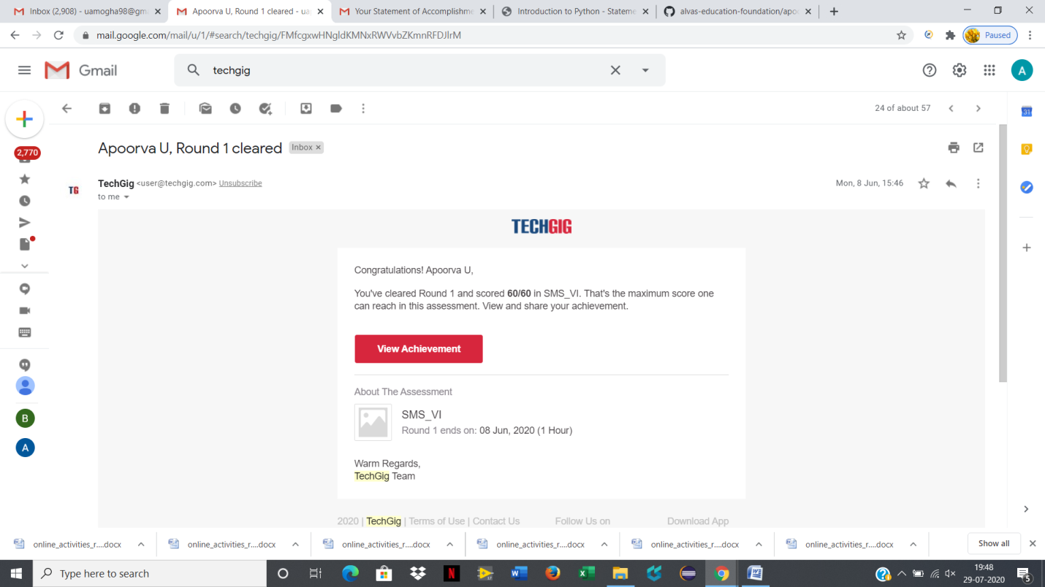

Certification Course Details: (Attach the snapshot and briefly write the report for the same)

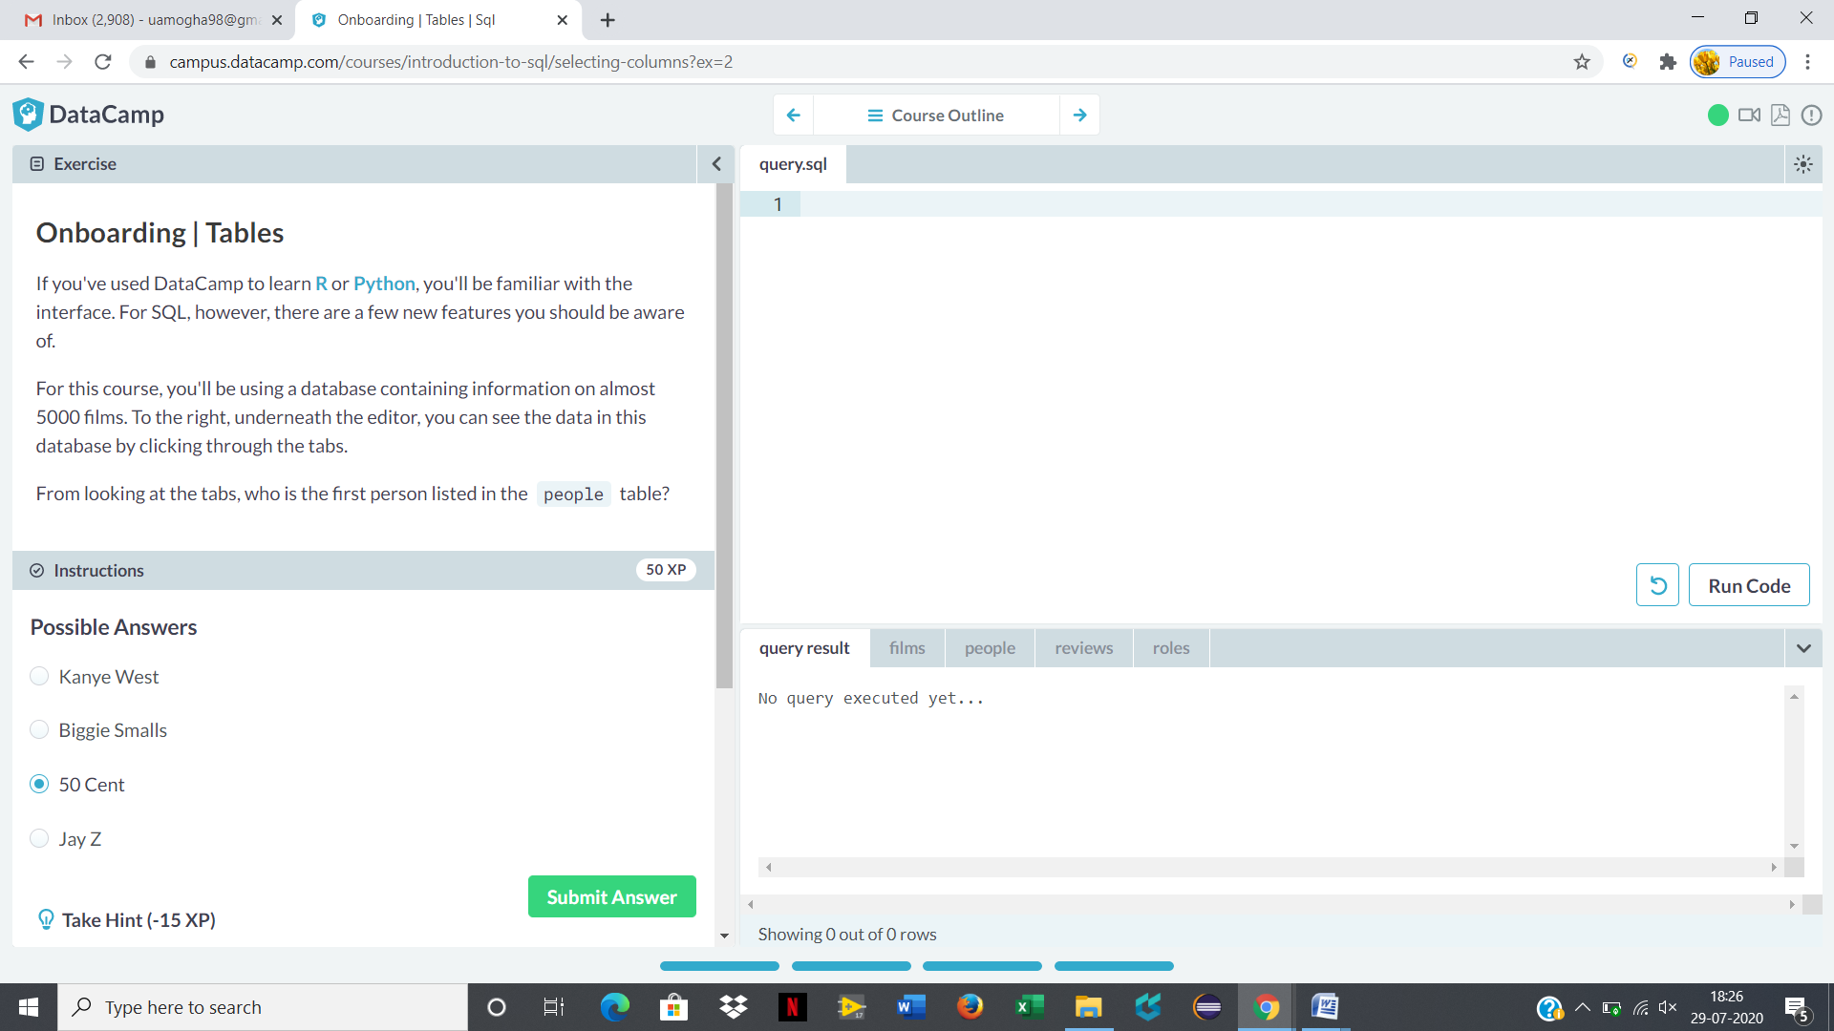

Coding Challenges Details: (Attach the snapshot and briefly write the report for the same)

Python program to print boundary element of matrix

MAX=100

def printBoundary(a,m,n):

sum =0

for i in range(m):

for j in range(n):

if(i==0):

sum +=a[i][j]

elif(i==m-1):

sum +=a[i][j]

elif(j==0):

sum +=a[i][j]

elif(j==n-1):

sum +=a[i][j]

return sum

#Driver code a=[[1,2,3,4],[5,6,7,8],

[1,2,3,4],[5,6,7,8]]

sum =printBoundary(a,4,4)

print("Sum of boundary elements is", sum)